**Task 1: Dynamic Student Report Card Using Destructuring and Template Literals**

**Problem Statement:**

You are given a student object that contains the details of a student including name, roll number, and marks in 5 subjects.

Using object and array destructuring and template literals, write a program to generate a formatted report card in the console.

**Your program should:**

* Calculate the total and percentage.
* Use destructuring to extract the marks.
* Use template literals to display a multi-line summary like:

Report Card for Riya (Roll No: 101)

-----------------------------------

Subjects: Math: 85, Science: 90, English: 78, History: 88, Art: 92

Total Marks: 433

Percentage: 86.6%

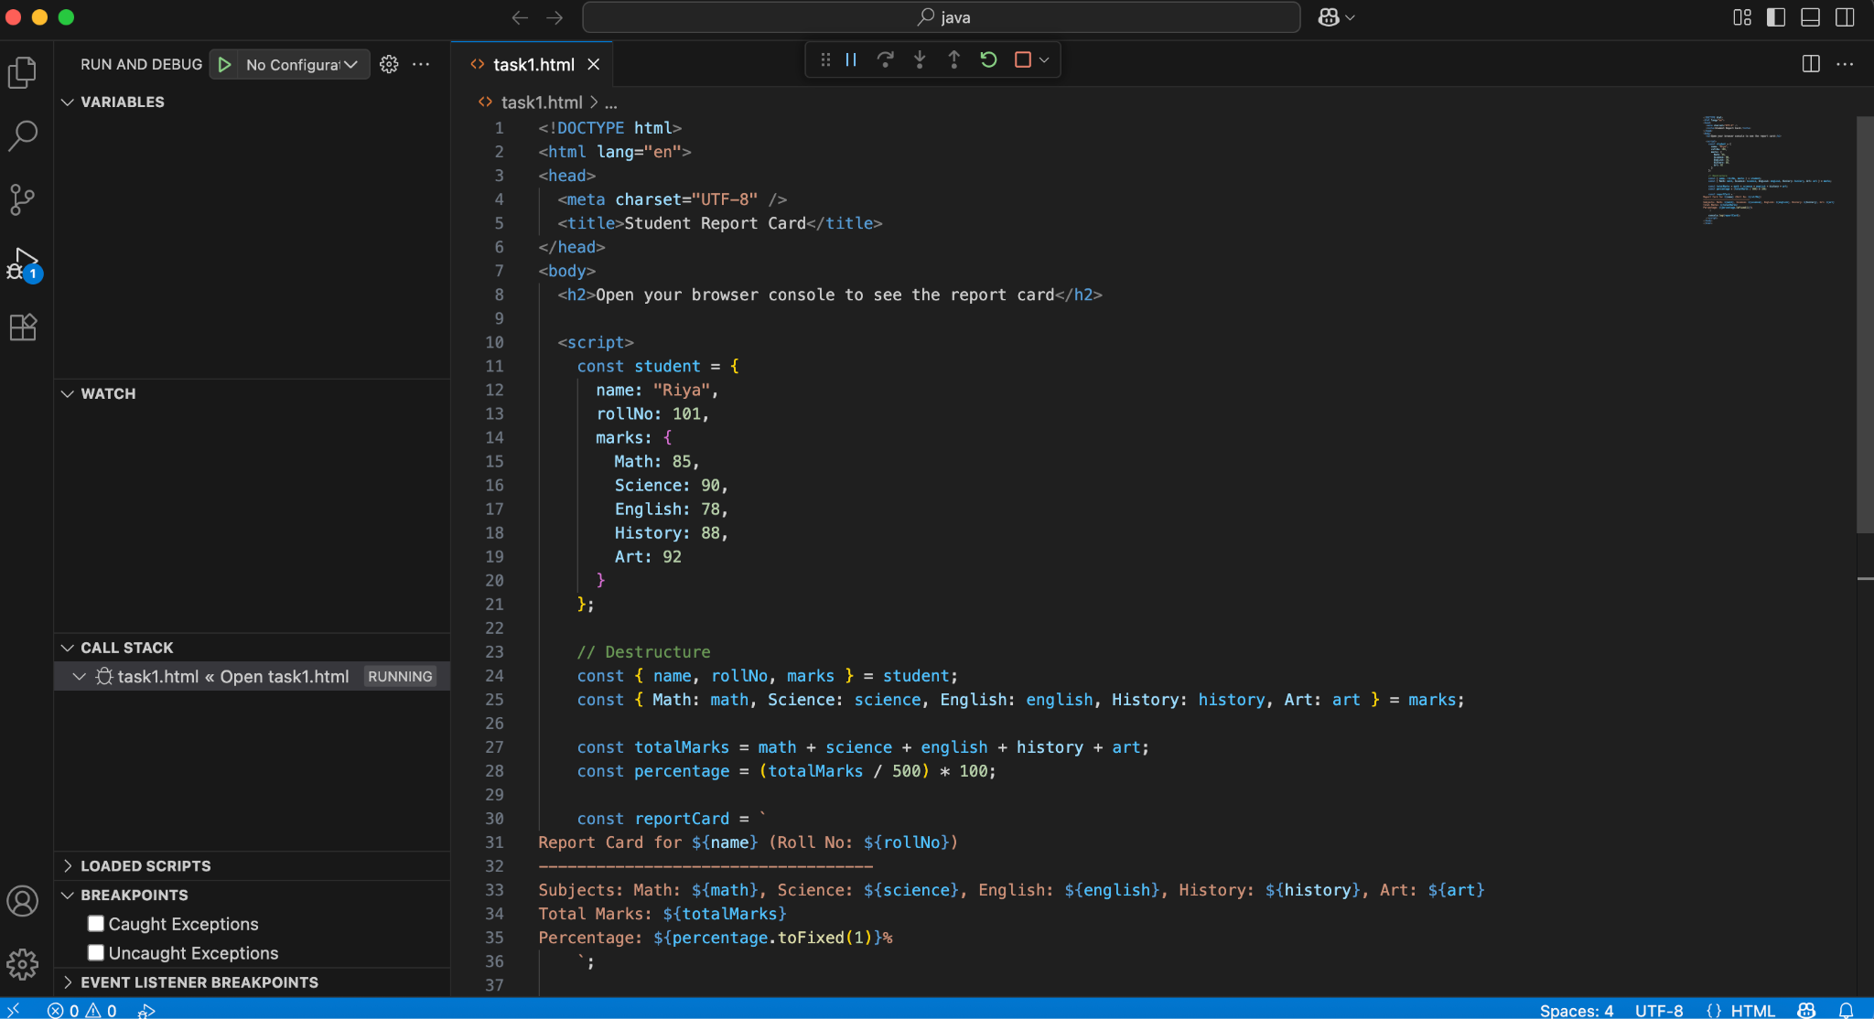

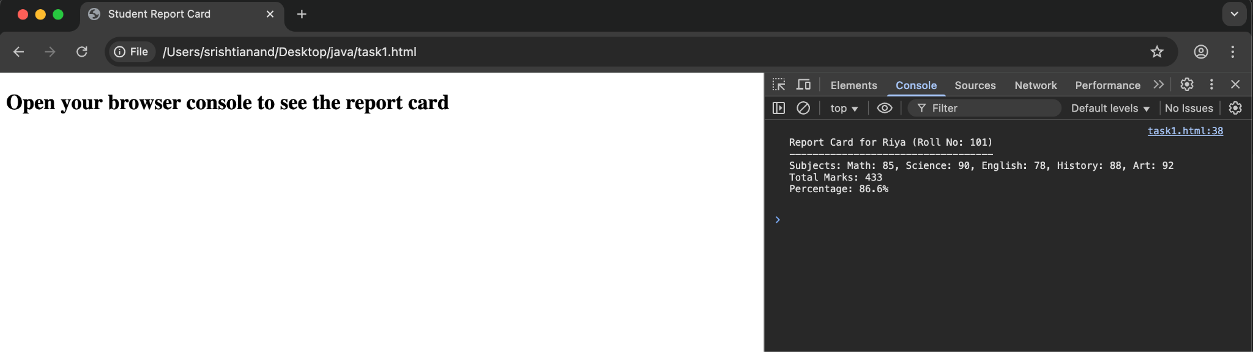

**Task 2: Build a Custom Greeting Generator with Default Parameters and Arrow Functions**

Problem Statement:

* Write a function named generateGreeting that:
* Takes in name, role, and location as parameters (all with default values).
* Uses an arrow function to return a greeting like:

"Hello [name]! Your role is [role] and you are currently in [location]."

**Requirements:**

* Do not use function keyword.
* Use template literals for message construction.
* Call the function with different combinations of arguments and no arguments.
* Only one function should handle all variations without breaking.

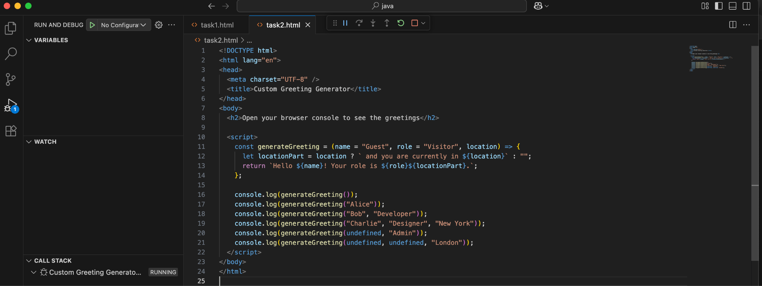

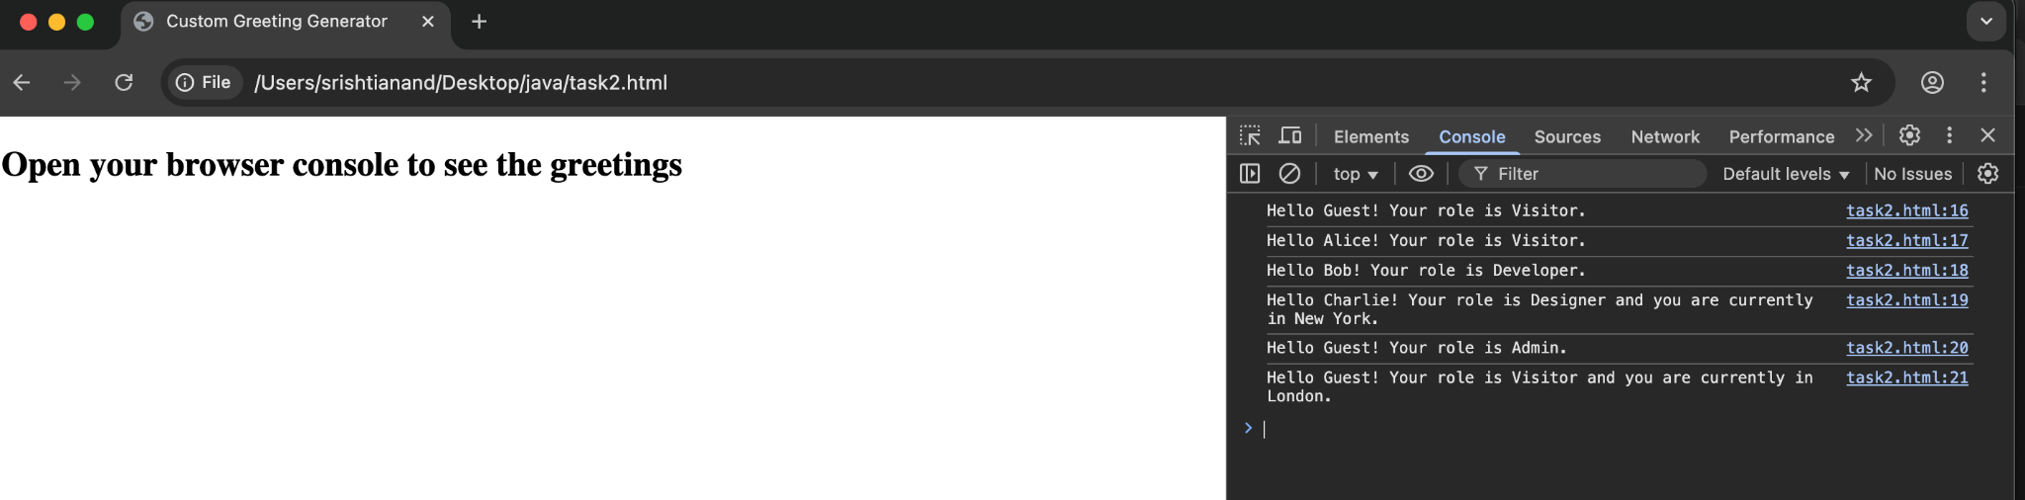

**Task 3: Implement a Data Type Analyzer (without typeof)**

**Problem Statement:**

Create a function analyzeData that takes any input and prints:

* What kind of primitive or reference type it is (without using typeof).
* Whether it’s mutable or immutable.
* A summary message.

You cannot use typeof, but must still determine if it's:

* string, number, boolean, undefined, null, symbol, bigint
* array, object, function

You must figure out creative ways to determine the type, such as using constructor checks, Array.isArray, etc.

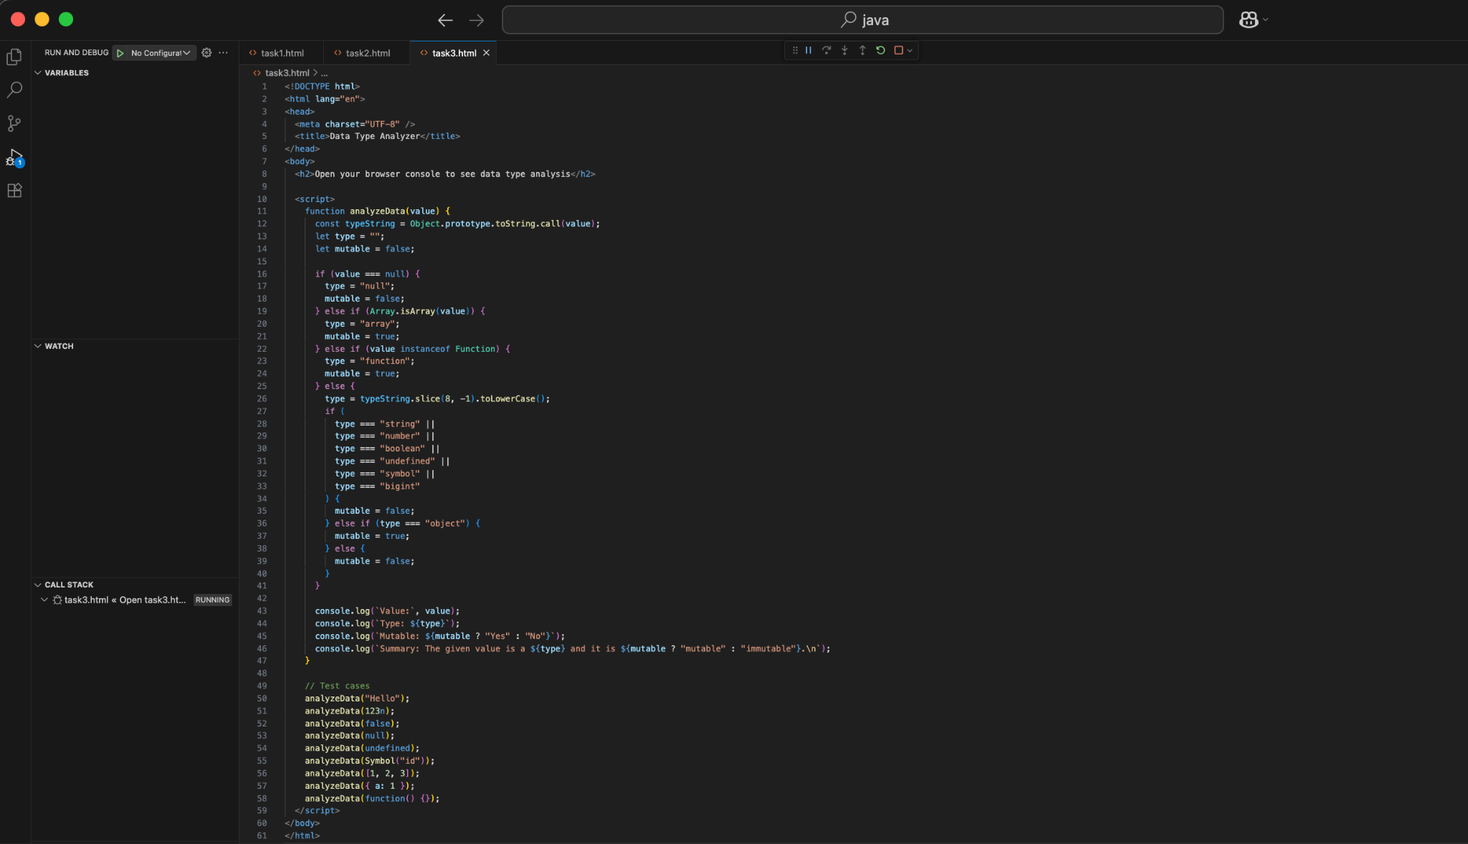

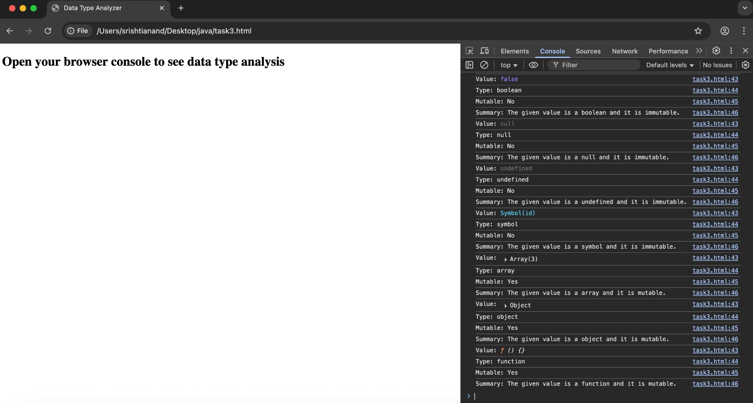

**Task 4: Color Mixer using Destructuring and Spread/Rest Operators**

**Problem Statement:**

Write a program that:

* Takes two arrays of colors from the user (e.g., ["red", "green"] and ["blue", "yellow"]).
* Merges the arrays using the spread operator into a new array called palette.
* Extract the first and last colors from the palette using array destructuring.
* Collect the middle colors using the rest operator.
* Display a message like:

"Main colors: Red and Yellow. Others in the palette: Green, Blue."

You are not allowed to use loops or array indexing manually.

